Naan mudhalvan project

Subscribers Galore: Exploring World’s Top YouTube Channels

College: Arignar Anna Government Arts College for Women, Walajapet,

Ranipet District-632 513

Department Of Mathematics



Subscribers Galore: Exploring World’s Top YouTube Channels

Submitted By

Team Leader: D.Oviya Priya

Team Members:

1) D. Oviya Priya

2) G.Priya

3) S.Pavithra

4) P. Revathi

**Introduction**

Overview

“In the vast digital landscape of online video content, You Tube reigns supreme as the go-to platform for creators and audiences alike.

With millions of channels and billions of videos, YouTube offers a kaleidoscope of entertainment, education, and inspiration.

From the realms of gaming and technology to the heartwarming world of vlogs and the educational wonders of science, we’ll delve into the stories, personalities, and captivating content that defined YouTube’s finest.

Objectives

The Objectives of Subscribers Galore: Exploring World’s Top YouTube Channels are as follows:

1 .The Reigning King of YouTube:

With over 110 million subscribers whose real name is one of the most recognizable and influential figures on YouTube.

2. The Music Mogul:

This Indian music label has taken the world by storm, featuring a vast array of music videos, and cultural content.

3. Exploring the world:

They transport viewers to the far corners of the earth, showcasing the wonders of nature, science, and culture. It’s a testament to the enduring appeal of factual, well-produced content.

4. Education Meets Entertainment:

With its colorful animations and catchy nursery rhymes, it has captured the hearts of parents and children Worldwide. Their commitment to creating quality enter content is evident in their massive subscriber count.

5. Sports and Entertainments:

Combining sports, comedy, and impressive trick shots, dude Perfect has earned a massive following. These five friends from Texas have made a name for themselves with their jaw-dropping stunts and infectious enthusiasm.

6. A Culinary Delight:

It features celebrity guests answering questions while eating progressively spicier hot wings. The mix of food, pop culture, and engaging interviews has made it a must-watch for millions.

7. The Science of Entertainment:

Mark Robber, a former NASA engineer, has found a unique niche on YouTube by blending science and entertainment. His Inventive experiments, DIY gadgets, and educational content make science fun and accessible to a broad audience.

**Problem definition and design thinking:**

**Empathy map:**

Empathy maps help identify patterns and themes are important to your project, enabling you to understand the real problem to be solved.

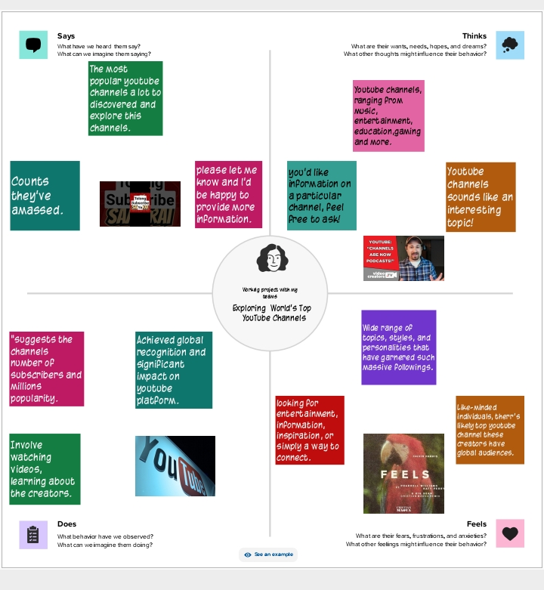

**Ideation and Brainstorming map:**

An ideation mind map is a visual diagram that helps you organize and structure your thoughts and ideas. It works by creating a central idea or concept, and then branching out into smaller, related ideas that connect to the central idea.

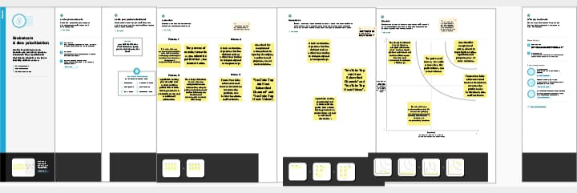

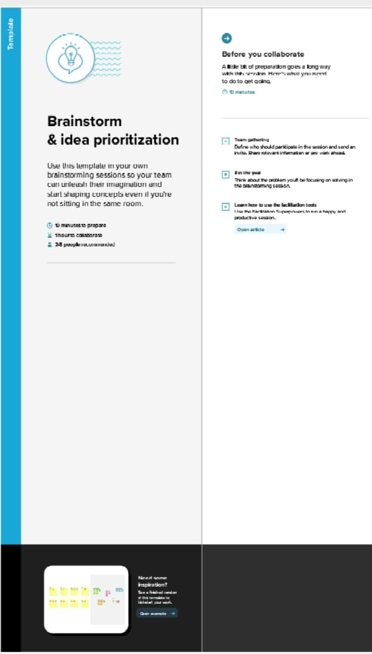

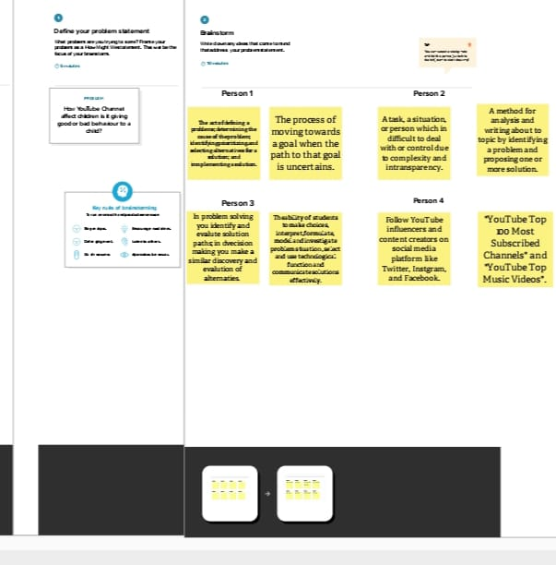

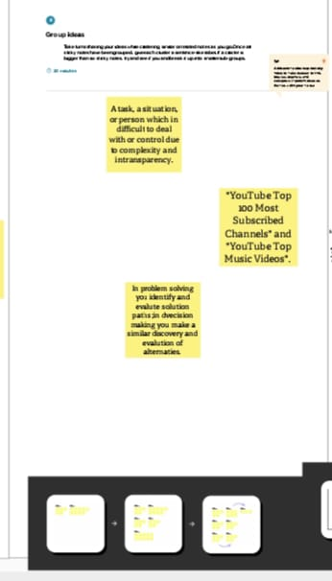

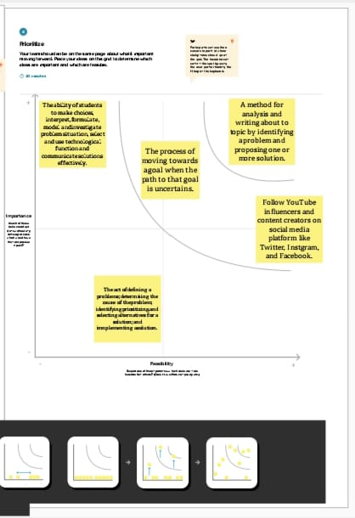

Source of Data

Data is open available on Kaggle which is made available Ministry of Agriculture and Farmers Welfare of India

https://www.kaggle.com/datasets/rajkumarpandey02/list-of-most-subscribed- YouTube -Channels-in-World

**Worksheets:**

1. **Rank Wise Channel**

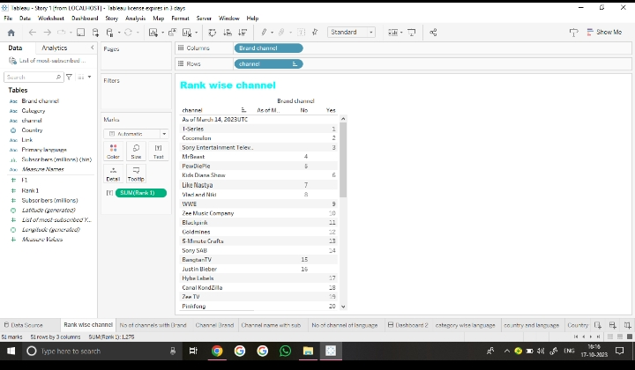

1. No of channels with brand

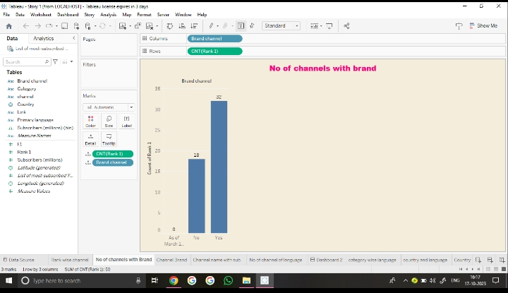

1. channel brand

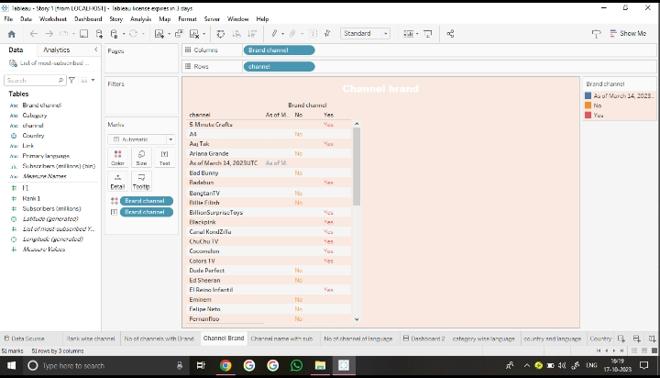

1. Channel name with subscribers

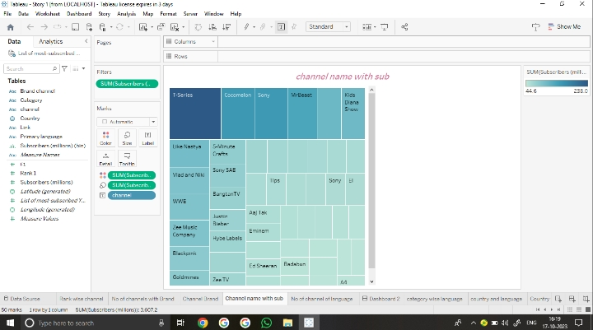

1. No of channel of Language

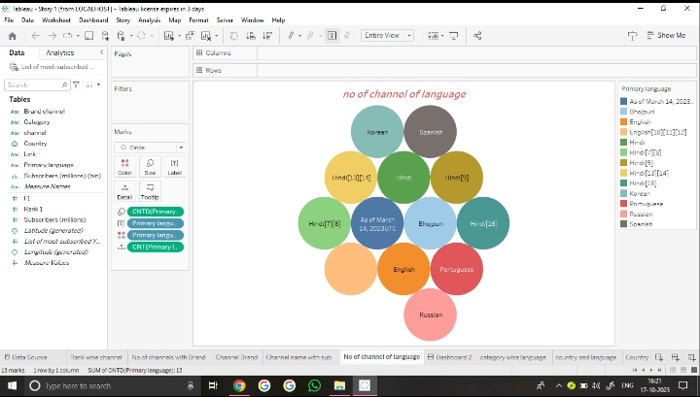

1. Category Wise language

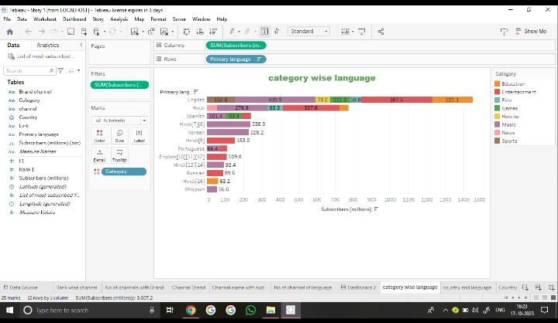

1. Country and Language

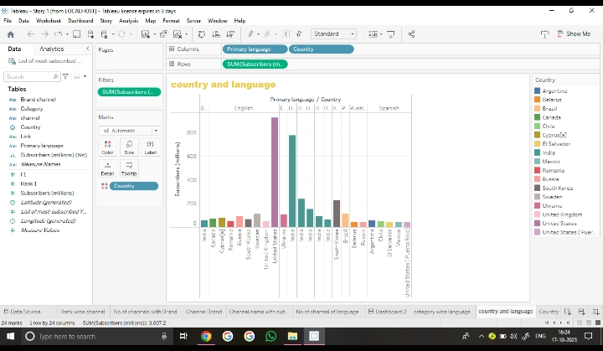

1. Country Wise Subscribe

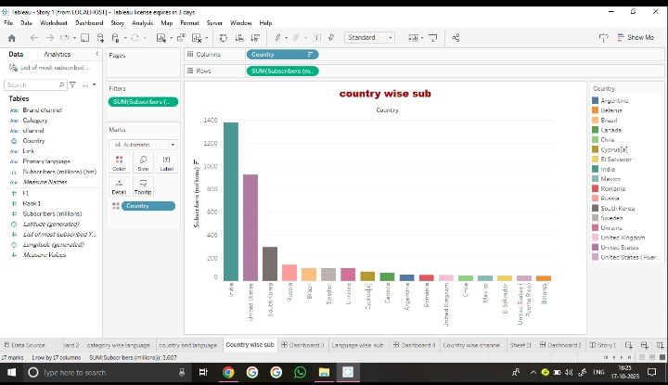

1. Language Wise Subscriber

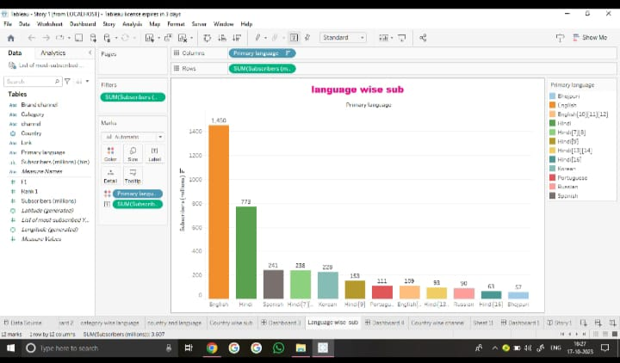

1. Country Wise Channels

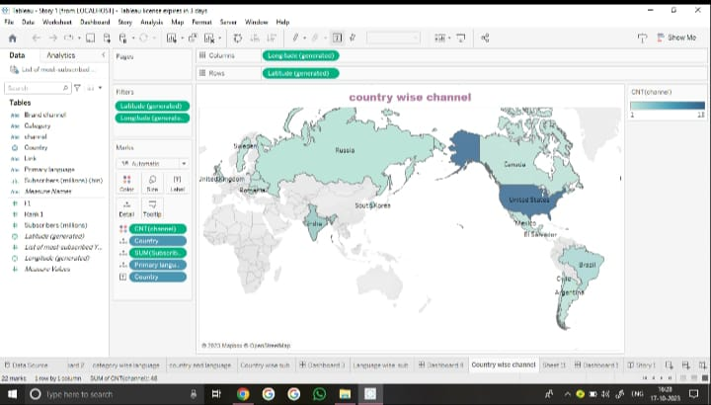

Dashboard: 1

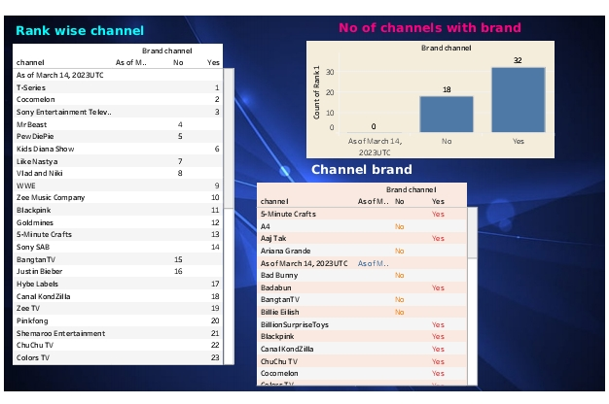

Dashboard: 2

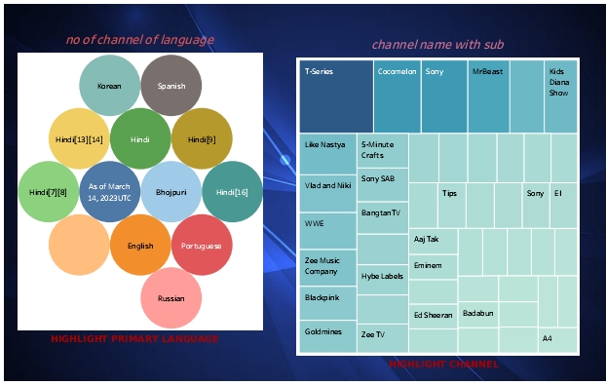

Dashboard: 3

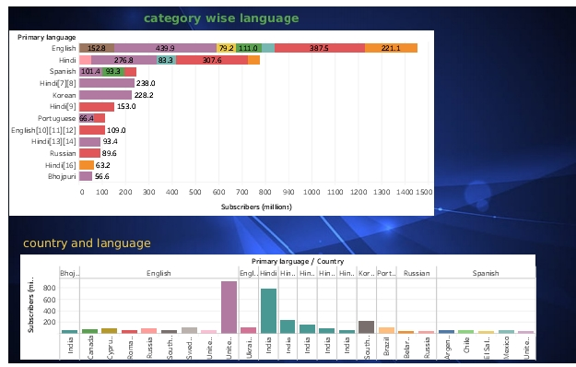

Dashboard: 4

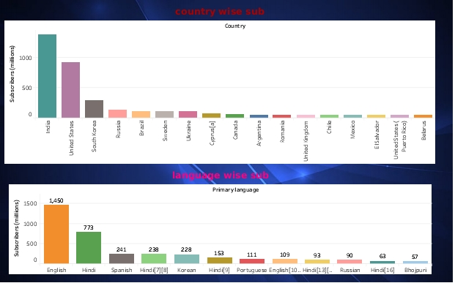

Story

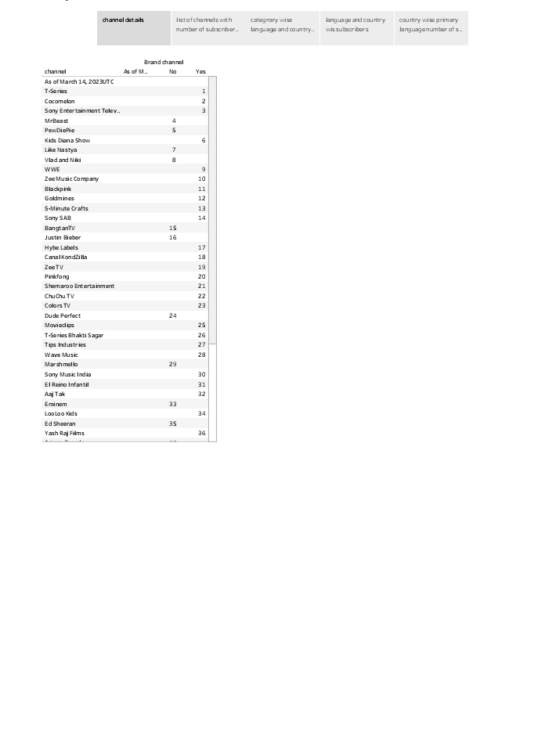

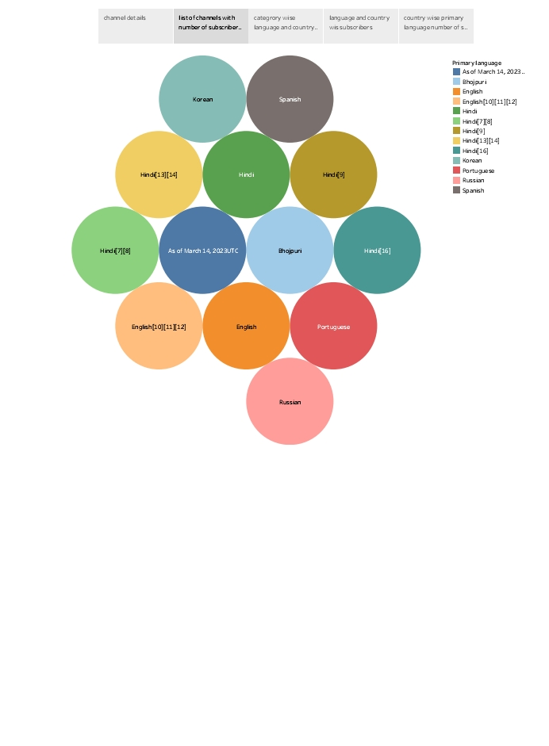

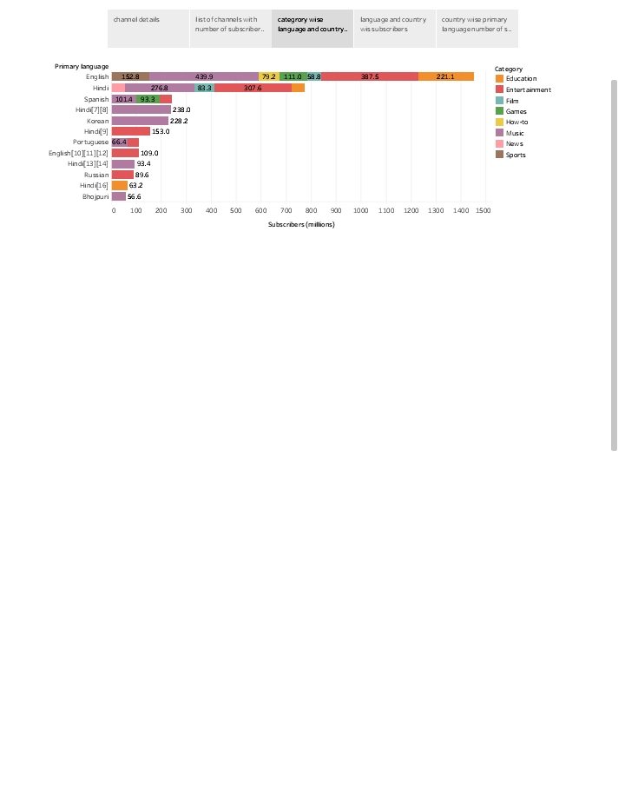

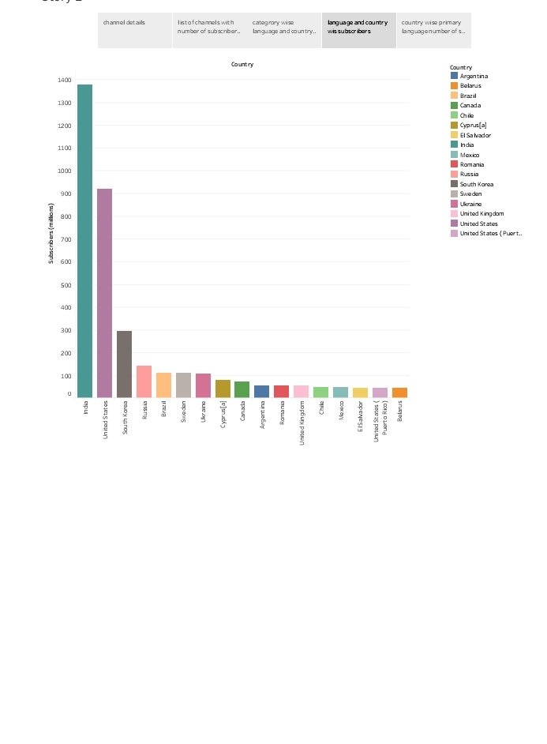

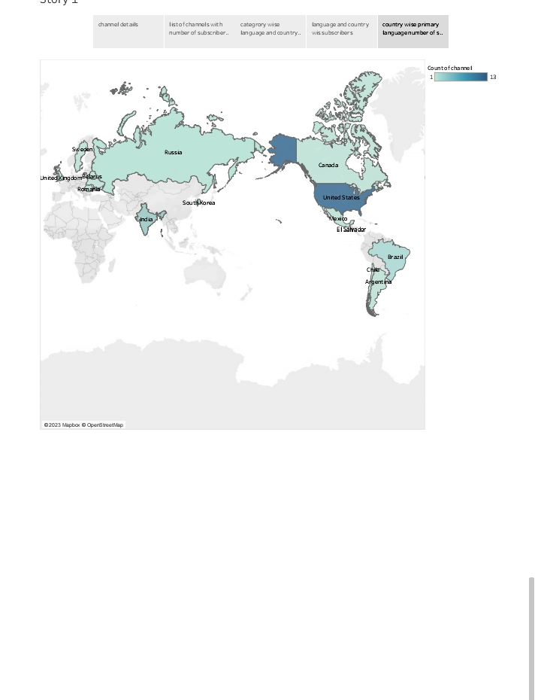

Advantages

1. Wide Reach: Top YouTube channels can reach a vast global audience, making it an excellent platform for content creators and business to gain exposure.

2. Monetization: Popular channels can earn a signification income through ads, sponsorship, merchandise, and other revenue stream.

3. Creativity: Content creators have the freedom to produce a wide range of content, fostering creativity and self-expression.

4. Community Building: Channels can build a loyal and engaged community of followers, creating a sense of belonging and support.

5. Educational: Many YouTube channels provide valuable educational content, helping people learn new skills or gain knowledge.

Disadvantages

1. Competition: the platform is highly competitive, making it challenging to stand out and gain a substantial following.
2. Content Quality: maintaining high-quality content consistently can be demanding and time-consuming.
3. Copyright Issues: Creators can face copyright infringement claims, leading to demonetization or even channel takedowns.
4. Negative Comments: Dealing with negative comments and online harassment is a downside for many creators.
5. Algorithm Changes: YouTube’s algorithms can affect a channel’s visibility and discoverability, which can be unpredictable.

It’s essential to consider these factors in the context of the specific channels you’re interested in, as the advantages and disadvantages can various used on factors like, niche, content quality, and engagement.

Applications

To explore the World’s top YouTube channels, you can use the YouTube application . here’s how to do it:

1. YouTube Search: Open the YouTube app or go to the YouTube website in your browser. Use the search bar at the top to enter keyword related to the type of channels you want to explore, such as “top gaming channels”, top beauty channels”, or “top travel channels”.
2. Top Lists: Many website and YouTube-related publications compile lists of the top YouTube channels in various categories. You can search for these lists online and find recommendations.
3. YouTube Trends: YouTube offers a “Trending” section that features popular videos and channels. You can check this section for treading content.
4. Subscription Recommendations: YouTube’s algorithm provides personalized channel recommendations based on your viewing history. You can check the “Recommendations” section to discover new channels.
5. Social Media: Follow YouTube-related accounts and influencers on social media platform like Instagram, Twitter, or Reddit. They often share their favorite channels and content.
6. YouTube Awards: YouTube holds annual awards like the YouTube Streamy Awards, which popular content creators. You can explore the winners and nominees to discover top channels.
7. YouTube Charts: YouTube provides official charts for various countries showcasing the most-viewed and channels and videos.

Conclusion

As of my last knowledge update in September 2021, I can’t provide the most up-to-date information on the world’s top YouTube channels.

YouTube channels ranking can change frequently. To find the current top YouTube channels, I recommend checking online sources like Social Blade or YouTube’s official trending and top charts.

These sources can give you the most recent data on popular channels.

Summarize key findings and insights.

Reiterate the importance of YouTube channels in the media landscape.